Table of Contents
- Introduction
- Manual Test Procedures
2.1 ATAL
2.2 ATNL
2.3 ATPB
2.4 STUFC
2.5 STPCB
2.6 STCFCPA
2.7 STCFCPC
2.8 STCMM
2.9 STM
2.10 STMA
2.11 STCSEGT
2.12 STCSTM
2.13 STCTOR
2.14 GPIOs test case ( STGPC, STGPIR, STGPIRH, STGPOR, STGPOW)
2.15 STDICPO
- Code Change Summary
3.1 STPTOT
3.2 STVRX

1. Introduction
In this Document:
- manual testing procedures for all 19 commands are covered.
- It mentions the two code fixes and the reason for the changes.
2. Manual Test Procedures:
Here are the step-by-step manual testing procedures for all 19 commands, including their expected outputs.

2.1. ATAL
- The default mode is ATNL (Normal Length, ATAL Off).
- Technically, ATAL should allow requests and responses greater than 7 bytes.
Step 1: Use the following command sequence:
STRSTNVM
0902
0902090209020902
ATAL
0902090209020902
Step 2:
Based on terminal output, after enabling ATAL, it should allow requests greater than 7 bytes, but it does not.
Responses greater than 7 bytes are already acceptable even without using ATAL.
Conclusion:
This command may not be related to ISO-15765.

2.2. ATNL

The default is ATNL ON (Normal Length, ATAL Off).
- Technically, this should restrict requests and responses greater than 7 bytes.
Step 1: Use the following sequence:
STRSTNVM
0902
ATAL
0902
ATNL
0902
Step 2:
From terminal observation, by default it should not accept responses greater than 7 bytes, but it does.
Requests greater than 7 bytes are already not acceptable in any case.
Conclusion:
This command may also not be related to ISO-15765.

2.3. ATPB
This command sets the USER A and USER B protocol settings. Additionally, programmable parameters from 2B–2F are related to these protocol settings. The behavior of ATPB and these PPs matches the STN and is partially implemented in our code. However, to make them fully functional, additional commands would need to be added. These commands were not part of the current requirements, but we expect they may be needed in future updates if required.

2.4. STUFC
When we configured the flow-control pins using this command, we were not able to observe any functional response. Only the CTS pin is exposed on the STN breakout board, and it always remains low regardless of the STUFC command settings.

2.5. STPCB
This command turns automatic check-byte calculation and verification on/off.
- When off, OBDLink will not append a checksum byte to transmitted messages or verify the checksum for received messages.
- This command does not apply to CAN protocols, where CRC is always enforced.
Reference: STN2120 Programming Manual (stn11xx21xx_frpm_d)

2.6. STCFCPA
This command should add Control Flow Pairs used for ISO-TP communication (e.g., PID 0902). However, we do not see any change in responses, whether using normal requests or STM bus monitoring.
Step 1: Run the following command sequence:
0902
ATH1
0902
STFAC
0902
STCFCPA 7E0,7E8
0902
STFFCA 7E8,FFF
0902
Step 2:
When all filters are removed, 0902 returns NO DATA.
Even after adding flow control pairs using STCFCPA, it still returns NO DATA.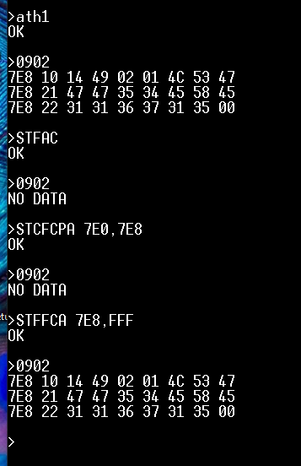
Step 3: Using STM bus monitoring
ATH1
STM (send packet: header 7E0, len 8, data: 02 09 02 00 00 00 00 00)
STCFCPA 7E0,7E8
STM (send packet again)
Step 4:
The device does not send a flow-control packet after receiving the First Frame.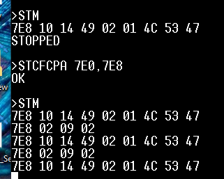
Conclusion:
STCFCPA is intended to add flow-control address pairs, but we could not find any part of the code where they are actually used. Currently, the code only stores the pairs in a buffer with no implementation logic.

2.7. STCFCPC
Conclusion:
This command removes flow-control address pairs. Similarly, we found no place in the code where these pairs are used. The implementation simply removes entries from the buffer.

2.8. STCMM
Step 1:
Using this command before STM or STMA does not produce any visible change in terminal output.
This command controls whether the STN will send ACK frames or not.
However, when testing with a CAN analyzer, the ACK bit is always present, likely because no TX errors occur.
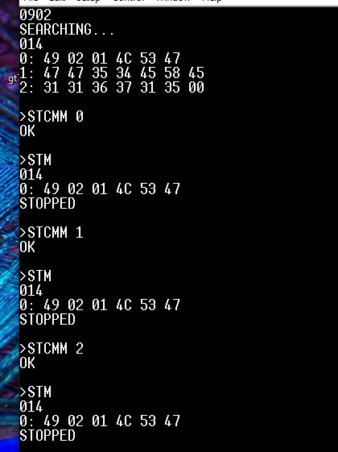

2.9. STM
Step 1:
After STRSTNVM, send 0902 so the device automatically loads filters, or manually set filters using ATSH.
Step 2:
Use STM, then on the CAN bus send:
- Header 7E8, data: 02 09 02 00 00 00 00 00 twice
- Header 777, same data once
The message with header 777 is filtered out and not received.
Step 3:
Enable ATCAF 0 and repeat the test.
Step 4:
Enable ATH1 and repeat again.
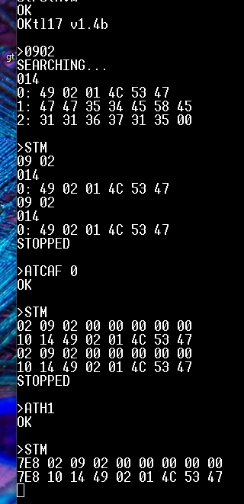
Conclusion:
STM monitors only messages that match the configured filters. It requires a second CAN device for testing.

2.10. STMA
Step 1:
After STRSTNVM, send 0902 so the device loads filters, or manually sets ATSH.
Step 2:
Enable ATH1, then use STMA.
In 11-bit mode, too many error frames appear due to the Freematics device, so we performed tests in 29-bit mode.
Set Freematics to 29-bit and use STP34 or follow:
STRSTNVM
0902
STMA
Then transmit:
- Header 7E8, data: 02 09 02 00 00 00 00 00 once
- Header 777, data: 02 09 02 00 00 00 00 00 once
You will see the message with header 777, but since the emulator does not respond, only the request appears.
Step 3:
Enable ATCAF 0 and repeat.
Step 4:
Enable ATH1 and repeat.
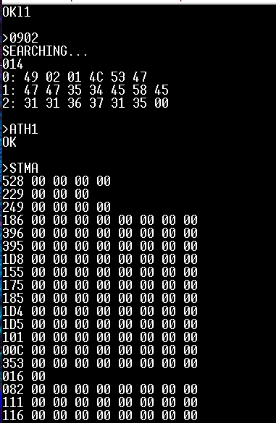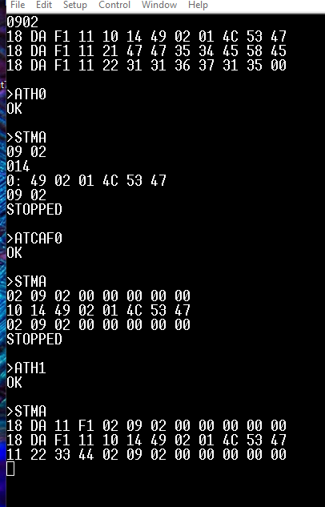
Conclusion:
STMA monitors all CAN messages and requires a second CAN device.

2.11. STCSEGT
Our requirement only covers ISO-15765, where:
- OBD-II PIDs are defined such that Mode + PID + Parameters always fit in a single CAN frame.
- ISO-15765-4 requires multi-frame only for responses, not for requests.
From tests with ATAL and ATNL, requests never exceed 8 bytes.

2.12. STCSTM
In a Flow Control frame, the 3rd byte represents STmin.
On the bus, this value is always 0 by default, and changing it using STCSTM had no effect, the STmin byte remained unchanged.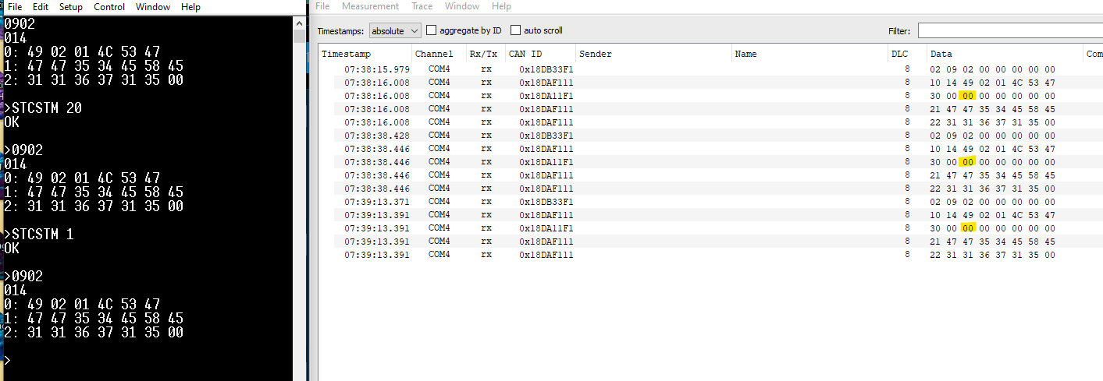

2.13. STCTOR
We observed no change in timeouts despite testing with:
- ATCFC
- ATFCSM
- ATFCSD
- STFFCC
Example:
We set the consecutive-frame timeout to 5 seconds, changed the flow control data accordingly, and sent 0902.
However, the response did not wait for 5 seconds after the Flow Control message as expected.
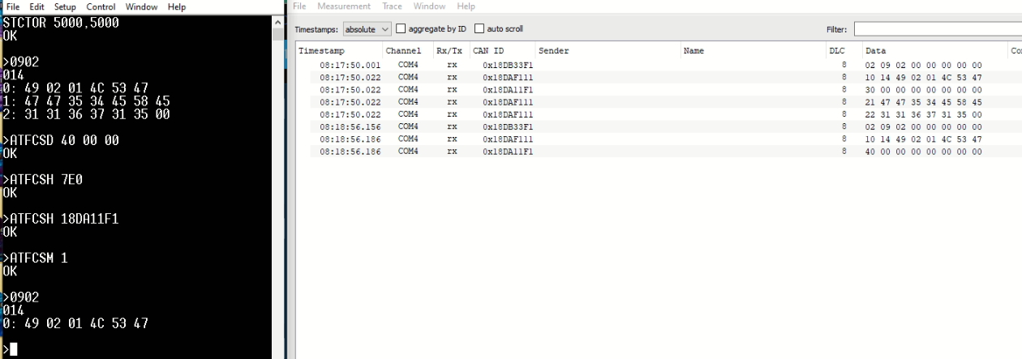

2.14 GPIOs Test Case (STGPC, STGPIR, STGPIRH, STGPOR, STGPOW)
Step 1:
Connect an LED to CN3/3 (GP35 on the STN chip) with a current-limiting resistor, ensuring the positive terminal is on the pin side.
Connect a push button to CN3/4 (GP34 on the STN chip), powered with 3.3V.
Step 2:
Configure GP35 as output and GP34 as input with pull-down using the STGPC command:
STGPC 35:O, 34:I:D1
Step 3:
Check pin states using STGPIR 35,34, STGPIRH 35,34, and STGPOR 35,34.
The response will show (0,0), (00), and (0,0) because the output is not set HIGH and the button is not pressed.
Step 4:
Run:
STGPOW 35:1, 34:1
This writes the latch values to both pins.
After running STGPOR 35,34, both pins will show (1,1) and the LED will turn ON.
However, reading input using STGPIR 34 will still show 0 because the input pin is LOW when the button is not pressed.
Step 5:
Press the button on GP34 and check the response using STGPIR 34 and STGPIRH 34.
The values will change to (1) and (01), confirming the input state update.
2.15. STDICPO
Step 1: Run ATZ, ATD, and ATWS, then check STDICPO. You will see that the count does not update after software resets.
Step 2: Now perform a hard reset using the button shown in the diagram. You will notice that the device restarts (as indicated by the red block). After that, check STDICPO again, the count is updated. In my case, it is now 3 because the device restarted twice.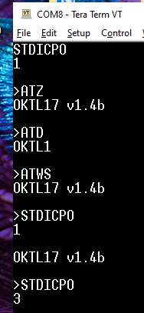 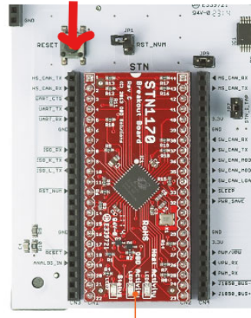

3.1 Code Changes
Two recent code updates were identified as hard fixes. Below is the technical justification for both changes and updates.
3.1.1 STPTOT
Previously in the dsPIC code, when the STP command was used, it was incorrectly resetting the timeout. To correct this, I added logic to compare the value: if the provided value was greater, it used that value; if it was smaller, it used the default value. This logic was implemented in two places in the code. Later, I removed one of them but accidentally forgot to remove the second occurrence. Now, all of that logic has been removed, and the global default timeout of 50 ms is used for all protocols since we are only working with ISO-15765. Additionally, for STPTOT, the timeout will adjust accordingly.
3.1.2 STVRX
The ADC was previously running at 10-bit resolution. We have now updated it to 12-bit resolution to match the STN results without using multiplication factors.

